Assignment -I B.NIKITHA(13/10/21)

1.What is Operating system? and its importance

Ans: An integrated system of programs which supervises the operations of the CPU, controls the input/output and storage functions of the computer system and provides various support services as the computer executes the application programs of users. An Operating System (OS) is a collection of system programs that controls and coordinates the overall operation of a computer system. Operating system is the most basic program within the computer system. These programs act as an interface between the hardware, application programs ,files and users.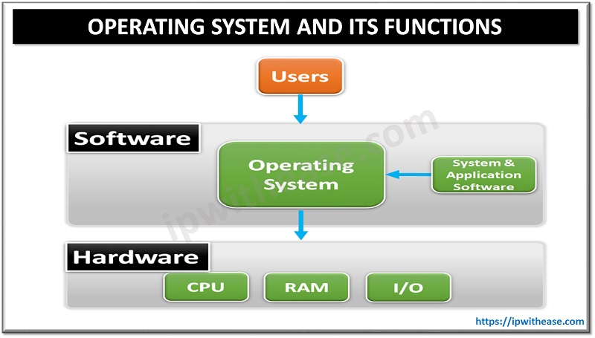

Importance

1. Operating system behaves as a resource manager. It utilizes the computer in a cost-effective manner. It keeps account of different jobs and the where about of their results and locations in the memory.
2. It schedules jobs according to their priority passing control from one program to the next. The overall function of job control is especially important where there are several users (a multiuser environment).
3. Operating system makes a communication link between user and the system and
4. helps the user to run application programs properly and get the required output.
5. Operating system could fetch the programs in the memory when required and not all the operating system to be loaded in the memory at the same time. Thus, giving the user the space to work in the required package more conveniently and easily.
6. Operating system helps the user in file management, making of directions, and saving files in them, is a very good feature provided by the operating system to organize data according to the needs of the user.

2. Explain major OS components

Ans: Components of operating system

An operating system is a large and complex system that can only be created by partitioning into small parts. These pieces should be a well-defined part of the system, carefully defining inputs, outputs, and functions. Although Windows, Mac, UNIX, Linux, and other OS do not have the same structure, most operating systems share similar OS system components, such as file, memory, process, I/O device management.

Application – File systems networking storage

OS - utilities GUI-CLI Drivers

Hardware - Memory Security Users

3. Explain 32 bit and 64-bit operating system and list out the differences

Ans: In computing, there exist two types of processors i.e., 32-bit and 64-bit. This type of processor tells us how much memory a processor can have access from a CPU register.

A 32-bit system can access 232 memory addresses, i.e., 4 GB of RAM or physical memory ideally, it can access more than 4 GB of RAM also.

A 64-bit system can access 264 memory addresses, i.e., 18-Quintillion bytes of RAM. In short, any amount of memory greater than 4 GB can be easily handled by it. Most computers made in the 1990s and early 2000s were 32-bit machines. The CPU register stores memory addresses, which is how the processor accesses data from RAM. A 64-bit register can theoretically referenc18,446,744,073,709,551,616 bytes, or 17,179,869,184 GB (16 exabytes) of memory. A major difference between 32-bit processors and 64-bit processors is the number of calculations per second they can perform, which affects the speed at which they can complete tasks. 64-bit processors can come in dual-core, quad-core, six-core, and eight-core versions for home computing.

4.Explain Mobile Operating Systems

Ans: Mobile operating system allows the user to run other different application software on the mobile, tablets, etc. Moreover, we can say that it is a type of operating system which is specially designed for mobiles, tablets, smartwatches, etc. Furthermore, they are a mixture of computer OS with some additional features for mobiles. Also, they are comparatively light and simple. mobile operating systems vary from device to device. Apple has their own system that they call iOS. Samsung phones, for example, use the Android operating system, and even Windows gets into the action with their own phones and Windows OS.

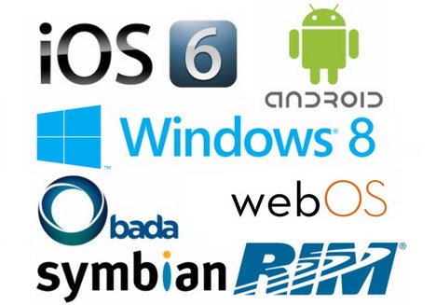

5. Explain EOS and EOL with an example

Ans: An end-of-life product (EOL product) is a product at the end of the product lifecycle which prevents users from receiving updates, indicating that the product is at the end of its useful life (from the vendor's point of view). At this stage, a vendor stops the marketing, selling, or provision of parts, services or software updates for the product. (The vendor may simply intend to limit or end support for the product.

For example, Microsoft marked Windows 98 for end-of-life on June 30, 2006. Software produced after that date may not work for it.

EOS is the same as EOA (end of availability). The name suggests exactly what it means, a date after which you will no longer be able to purchase the product directly from a manufacturer like NetApp or EMC. Sometimes this product may still be available through a third-party vendor, but the product itself will no longer be offered from its original company as it has always been in the past.